# PRACTICAL – 1

## Aim: Study Practical:

1. **LINUX Architecture**

## Types of OS- Linux, Flavors of LINUX UNIX, MAC, Window etc.

1. **Difference Between Lollipop and Marshmallow Operating System Version.**

**Architecture of Linux**

Linux Operating System has primarily three components

* **Kernel** − Kernel is the core part of Linux. It is responsible for all major activities of this operating system. It consists of various modules and it interacts directly with the underlying hardware. Kernel provides the required abstraction to hide low level hardware details to system or application programs.
* **System Library** − System libraries are special functions or programs using which application programs or system utilities accesses Kernel's features. These libraries implement most of the functionalities of the operating system and do not requires kernel module's code access rights.
* **System Utility** − System Utility programs are responsible to do specialized, individual level tasks.

## Architecture

The following illustration shows the architecture of a Linux system −

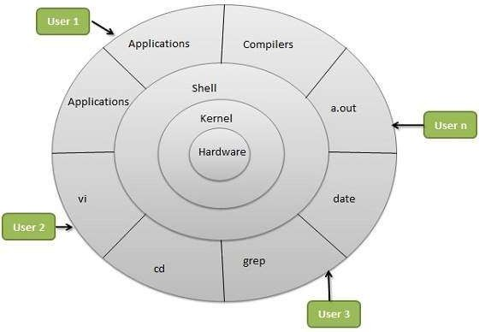

The architecture of a Linux System consists of the following layers −

* **Hardware layer** − Hardware consists of all peripheral devices (RAM/ HDD/ CPU etc).
* **Kernel** − It is the core component of Operating System, interacts directly with hardware, provides low level services to upper layer components.
* **Shell** − An interface to kernel, hiding complexity of kernel's functions from users. The shell takes commands from the user and executes kernel's functions. Linux provides a special interpreter program which can be used to execute commands of the operating system. It can be used to do various types of operations, call application programs. Etc
* **Utilities** − Utility programs that provide the user most of the functionalities of an operating systems.

## Different Shells in Linux

SHELL is a program which provides the interface between the user and an operating system. When the user logs in OS starts a shell for user. Kernel controls all essential computer operations, and provides the restriction to hardware access, coordinates all executing utilities, and manages Resources between process. Using kernel only user can access utilities provided by operating system.

## Types of Shell:

1. **The C Shell –** o Denoted as csh
   * Bill Joy created it at the University of California at Berkeley. It incorporated features such as aliases and command history. It includes helpful programming features like built-in arithmetic and C-like expression syntax.

### In C shell:

* + - Command full-path name is /bin/csh, ▪ Non-root user default prompt is hostname %, ▪ Root user default prompt is hostname #.

1. **The Bourne Shell –** o Denoted as sh o It was written by Steve Bourne at AT&T Bell Labs. It is the original UNIX shell. It is faster and more preferred. It lacks features for interactive use like the ability to recall previous commands. It also lacks built-in arithmetic and logical expression handling. It is default shell for Solaris OS.
   * For the Bourne shell the:

* Command full-path name is /bin/sh and /sbin/sh, ▪ Non-root user default prompt is $, ▪ Root user default prompt is #.

1. **The Korn Shell** o It is denoted as ksh
   * It Was written by David Korn at AT&T Bell LabsIt is a superset of the Bourne shell.So it supports everything in the Bourne shell.It has interactive features. It includes features like built-in arithmetic and C-like arrays, functions, and stringmanipulation facilities.It is faster than C shell. It is compatible with script written for C shell.
   * For the Korn shell the:
     + Command full-path name is /bin/ksh, ▪ Non-root user default prompt is $, ▪ Root user default prompt is #.
2. **GNU Bourne-Again Shell –** o Denoted as bash
   * It is compatible to the Bourne shell. It includes features from Korn and Bourne shell. o For the GNU Bourne-Again shell the:
     + Command full-path name is /bin/bash,
     + Default prompt for a non-root user is bash-g.gg$ ▪ (g.ggindicates the shell version number like bash- 3.50$), ▪ Root user default prompt is bash-g.gg#.

### Utilities –

Utility programs that provide the user most of the functionalities of an operating systems.

1. **a.out:** o "**a**.**out**" remains the default output file name for executables created by certain compilers and linkers when no output name is specified, even though the created files actually are not in the **a**.**out** format.
2. **date :** o date command is used to display the system date and time. date command is also used to set date and time of the system. By default the date command displays the date in the time zone on which unix/linux operating system is configured.You must be the super-user (root) to change the date and time.

* Syntax:
  + date [OPTION]... [+FORMAT]
  + date [-u|--utc|--universal] [MMDDhhmm[[CC]YY][.ss]]

### grep :

* The grep filter searches a file for a particular pattern of characters, and displays all lines that contain that pattern. The pattern that is searched in the file is referred to as the regular expression (grep stands for globally search for regular expression and print out).

### Syntax:

**grep [options] pattern [files]**

1. **Cd :** o cd command in linux known as change directory command. It is used to change current working directory. o Syntax:
   * $ cd [directory]

### What is the VI editor?

The VI editor is the most popular and classic text editor in the Linux family. Below, are some reasons which make it a widely used editor –

1. It is available in almost all Linux Distributions
2. It works the same across different platforms and Distributions
3. It is user-friendly. Hence, millions of Linux users love it and use it for their editing needs Syntax:

vi <filename_NEW> or <filename_EXISTING>

# 2.) Types of Operating System

### Operating System:-

Operating System performs all the basic tasks like managing files, processes, and memory.

### Batch Operating System :–

This type of operating system does not interact with the computer directly. There is an operator which takes similar jobs having the same requirement and group them into batches. It is the responsibility of the operator to sort jobs with similar needs.

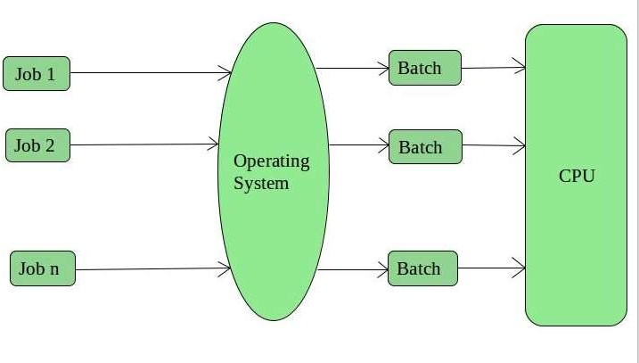

### Advantages of Batch Operating System: -

* + It is very difficult to guess or know the time required for any job to complete. Processors of the batch systems know how long the job would be when it is in queue
  + Multiple users can share the batch systems
  + The idle time for the batch system is very less
  + It is easy to manage large work repeatedly in batch systems

### Disadvantages of Batch Operating System: -

* + The computer operators should be well known with batch systems
  + Batch systems are hard to debug
  + It is sometimes costly
  + The other jobs will have to wait for an unknown time if any job fails

**Examples :** Payroll System, Bank Statements, etc.

### Time-Sharing Operating Systems: –

Each task is given some time to execute so that all the tasks work smoothly. Each user gets the time of CPU as they use a single system. These systems are also known as Multitasking Systems. The task can be from a single user or different users also. The time that each task gets to execute is called quantum. After this time interval is over OS switches over to the next task.

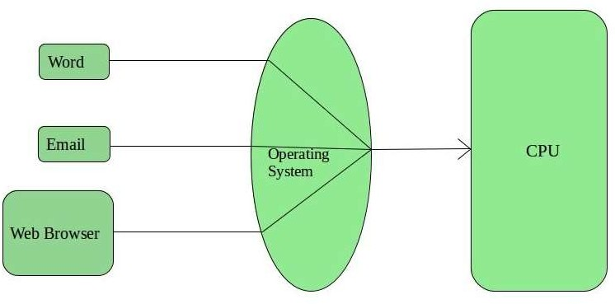

### Advantages of Time-Sharing OS:

* Each task gets an equal opportunity
* Fewer chances of duplication of software
* CPU idle time can be reduced

### Disadvantages of Time-Sharing OS:

* Reliability problem
* One must have to take care of the security and integrity of user programs and data
* Data communication problem **Examples:** Multics, Unix, etc. **3.Distributed Operating System: –**

These types of the operating system is a recent advancement in the world of computer technology and are being widely accepted all over the world and, that too, with a great pace. Various autonomous interconnected computers communicate with each other using a shared communication network. Independent systems possess their own memory unit and CPU. These are referred to as loosely coupled systems or distributed systems. These system’s processors differ in size and function. The major benefit of working with these types of the operating system is that it is always possible that one user can access the files or software which are not actually present on his system but some other system connected within this network i.e., remote access is enabled within the devices connected in that network.

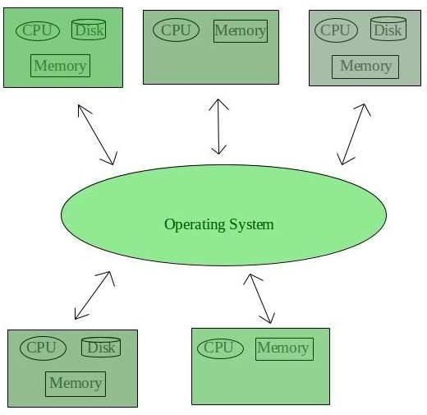

### Advantages of Distributed Operating System:

* Failure of one will not affect the other network communication, as all systems are independent from each other
* Electronic mail increases the data exchange speed
* Since resources are being shared, computation is highly fast and durable
* Load on host computer reduces
* These systems are easily scalable as many systems can be easily added to the network
* Delay in data processing reduces

### Disadvantages of Distributed Operating System:

* Failure of the main network will stop the entire communication
* To establish distributed systems the language which is used are not well defined yet
* These types of systems are not readily available as they are very expensive. Not only that the underlying software is highly complex and not understood well yet

**Examples :-** LOCUS, etc.

### Network Operating System :–

These systems run on a server and provide the capability to manage data, users, groups, security, applications, and other networking functions. These types of operating systems allow shared access of files, printers, security, applications, and other networking functions over a small private network. One more important aspect of Network Operating Systems is that all the users are well aware of the underlying configuration, of all other users within the network, their individual connections, etc. and that’s why these computers are popularly known as tightly coupled systems.

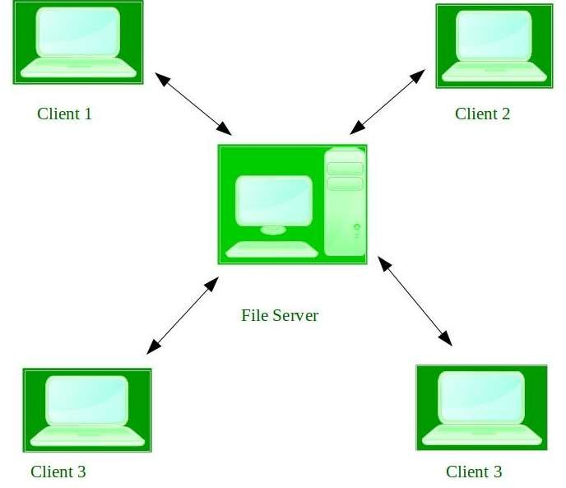

### Advantages of Network Operating System:

* + Highly stable centralized servers
  + Security concerns are handled through servers
  + New technologies and hardware up-gradation are easily integrated into the system
  + Server access is possible remotely from different locations and types of system

### Disadvantages of Network Operating System:

* + Servers are costly
  + User has to depend on a central location for most operations
  + Maintenance and updates are required regularly

**Examples:-** Microsoft Windows Server 2003, Microsoft Windows Server 2008, UNIX, Linux, Mac OS X, Novell NetWare, and BSD, etc.

### Real-Time Operating System :–

These types of OSs serve real-time systems. The time interval required to process and respond to inputs is very small. This time interval is called response time.

Real-time systems are used when there are time requirements that are very strict like missile systems, air traffic control systems, robots, etc.

* + Two types of Real-Time Operating System which are as follows:

### Hard Real-Time Systems:

These OSs are meant for applications where time constraints are very strict and even the shortest possible delay is not acceptable. These systems are built for saving life like automatic parachutes or airbags which are required to be readily available in case of any accident. Virtual memory is rarely found in these systems.

### Soft Real-Time Systems:

These OSs are for applications where for time-constraint is less strict.

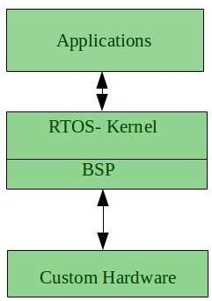

### Advantages of RTOS:

* + Maximum Consumption: Maximum utilization of devices and system, thus more output from all the resources
  + Task Shifting: The time assigned for shifting tasks in these systems are very less. For example, in older systems, it takes about 10 microseconds in shifting one task to another, and in the latest systems, it takes 3 microseconds.
  + Focus on Application: Focus on running applications and less importance to applications which are in the queue.
  + Real-time operating system in the embedded system: Since the size of programs are small, RTOS can also be used in embedded systems like in transport and others.
  + Error Free: These types of systems are error-free.
  + Memory Allocation: Memory allocation is best managed in these types of systems.

### Disadvantages of RTOS:

* + Limited Tasks: Very few tasks run at the same time and their concentration is very less on few applications to avoid errors.
  + Use heavy system resources: Sometimes the system resources are not so good and they are expensive as well.
  + Complex Algorithms: The algorithms are very complex and difficult for the designer to write on.
  + Device driver and interrupt signals: It needs specific device drivers and interrupts signals to respond earliest to interrupts.
  + Thread Priority: It is not good to set thread priority as these systems are very less prone to switching tasks.

**Examples:-** Scientific experiments, medical imaging systems, industrial control systems, weapon systems, robots, air traffic control systems, etc.

**Flavors of OS:**

### Linux:

* + Debian. ...
  + Gentoo. ...
  + Ubuntu. ...
  + Linux Mint. ...
  + Red Hat Enterprise Linux. ...
  + CentOS. ...
  + Fedora. ...
  + Kali Linux.

### UNIX:

* + - "Ken's new system" (→Unix) (1969)
    - UNIX Time-Sharing System v1 (1971)
    - UNIX Time-Sharing System v2 (1972)
    - UNIX Time-Sharing System v3 (1973)
    - UNIX Time-Sharing System v4 (1973)
    - UNIX Time-Sharing System v5 (1974) o UNSW 01 (1978)
    - UNIX Time-Sharing System v6 (1975) o Mini-UNIX (1977) o PWB/UNIX 1.0 (1977)
      * USG 1.0
      * CB UNIX 1 • UNIX Time-Sharing System v7 (1979) o UNIX System III (1981)
    - UNIX Time-Sharing System v8 (1985)
    - UNIX Time-Sharing System v9 (1986)
    - UNIX Time-Sharing System v10 (1989)

### Windows:

* Windows 95
* Windows 2000
* Windows XP
* Windows Vista
* Windows 7
* Windows 8
* Windows 8.1
* Windows 10
* Windows 11

### MacOS:

* + Mac OS X 10.0
  + Mac OS X 10.1
  + Mac OS X 10.2
  + Mac OS X 10.3
  + Mac OS X 10.4
  + Mac OS X 10.5
  + Mac OS X 10.6
  + Mac OS X 10.7
  + Mac OS X 10.8
  + Mac OS X 10.9
  + Mac OS X 10.10
  + Mac OS X 10.11
  + Mac OS X 10.12
  + Mac OS X 10.13
  + Mac OS 11
  + Mac OS 12
  + Mac OS 13

## Main Branches of Unix

Contemporary Unix implementations are either open-source (that is, free to download, use, or modify) or closed source (that is, proprietary binary files not subject to user modification).

These are the main Unix variants:

### Minix:

A Unix-like open-source project, rarely used by home users.

### Linux:

An open-source initiative to bring a Unix-like environment to both the desktop and server space. Linux is popular with home computer enthusiasts.

### Mac OS X:

The Apple desktop operating system.

### BSD (FreeBSD, DragonflyBSD, NetBSD, OpenBSD):

A branch from the earliest Unix specs, following the design principles of the Berkeley Software Distribution.

**AIX**:

A series of Unix-based operating environments developed by IBM for its servers.

### Solaris:

A proprietary server operating system based on Unix and developed by Sun Microsystems.

**Open Solaris**: An open-source variant of Solaris.

### HP-UX:

A series of Unix-based operating environments developed by HP for its servers.

### Open Server:

Based on FreeBSD and a closed source operating system. It is now owned by Xinuos. Previously known as SCO UNIX, it was developed by Santa Cruz Operation. SCO acquired the rights to the UnixWare operating system, portions of which became part of OpenServer.

**Common Consumer Distributions**

Over the years, different Linux flavors have enjoyed more or less popularity, but several stand out as being among the most commonly deployed on desktop computers. Some of the most commonly accessed distributions include:

### Mint:

A version of Ubuntu with additional software drivers and minor customizations.

### Debian:

A project that bills itself as a universal operating system. It has a significant market share and a robust base of applications.

### Manjaro:

Based on the Arch Linux project and supports extensive configurations.

### Ubuntu:

A significant player in the Linux market. Ubuntu offers an easy-to-use distribution that's beautifully designed and accessible despite language and disability barriers.

### Antergos:

Based on the Arch Linux project. This distribution offers a custom installer program.

### OpenSUSE:

A long-running German distribution that's the community version of the SUSE Linux commercial distribution.

### Fedora:

A community project based on Red Hat Linux (an operating system that was discontinued in 2004).

### Solus:

A built-from-scratch distribution from Ireland with a custom desktop environment called Budgie that looks like the old GNOME 2 desktop (GNOME is the default desktop environment on many major Linux distributions).

### Zorin:

A distribution intended to mimic the look-and-feel of Windows to help new Linux users transition away from the Microsoft Windows operating system.

### Elementary:

Based on Ubuntu and uses a custom desktop environment called Parthenon that resembles, in some ways, Mac OS.

## 3.)Difference Between Lollipop and Marshmallow Operating System Version

|  |  |
| --- | --- |
| Lollipop | Marshmallow |
| * Android Lollipop is the fifth major version of the Android mobile operating system   developed by google. | * Android marshmallow is the sixth major version of Android operating system. |
| * Codenamed Android L during development. | * Codenamed Android M during development. |
| * The main feature of this version is that it came with a major user interface built with material design to offer a paper-like feel to user through the UI. | * Additional features included a native support for fingerprint recognition, USB Type-C connector and an efficient ability to migrate data. |
| * Android lollipop does not support USB C. | * The USB C will enable the phone to charge faster and for the device to gain faster rates. |
| * Has only a limited amount of emojis are available. | * Has more than 200 emojis. |
| * Most of the items in the quick setting menu are actionable. A feature can be enabled or disabled just by tapping the top part of it. | * It is also made up of a quick setting feature which allows users to add, remove or rearrange specific settings. |
|  |  |
| * Android 5.1 Lollipop basic features are same as Kitkat. It has got similar Bluetooth, location, Wi-fi etc. | * Android 6.0.1 Marshmallow has newly added Quick setting, newly doze feature to improve battery life. |
| * Android Lollipop has a whopping 35.4% of users. | * Android Marshmallow, on the other hand, has a dignified 10.1% user base. |
| * Android 5.1 Lollipop has an exclusive recent app menu. | * Android 6.0.1 Marshmallow has a special fingerprint scanner. |